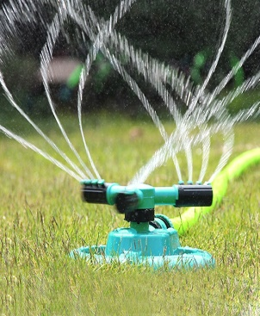
Village of New Denver Sprinkling Restrictions – Level 1
Effective July 25, 2022 there shall be no sprinkling between the hours of 10:00 am and 6:00 pm. Please check out the Village of New Denver’s website https://newdenver.ca/ for updates.

