

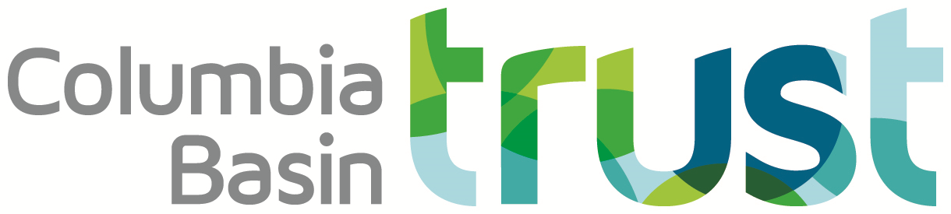

FOR IMMEDIATE RELEASE

December 9, 2021

**Free Arts and Culture Grant Writing Workshops**

**Columbia Basin** – Want to learn more about how to apply for arts and culture grants delivered by the Columbia Kootenay Cultural Alliance? Attend a free workshop with a CKCA representative, who will share how to apply and what to expect from the application process.

Individuals working in all artistic disciplines as well as arts and cultural organizations residing in the Columbia Basin are invited to attend the workshops.

The Columbia Basin Trust’s arts and culture grants are managed and administered by CKCA. The Trust proudly supports initiatives and projects that highlight Basin arts and culture.

Working with community arts councils, individual artists, performers, writers, and arts and cultural organizations, the goal of the Columbia Kootenay Cultural Alliance is to build long-term sustainability for artists and to strengthen and support arts and cultural organizations.

Workshops start in December and run through January, online.

**Workshops are FREE. Pre-registration is required.** For dates and to register visit:[www.basinculture.com](http://www.basinculture.com) .

More information and general funding policies are available online at [www.basinculture.com](http://www.basinculture.com). The 2022 funding program information is expected to be launched mid-January 2022.

Further questions? E-mail [admin@wkartscouncil.com](mailto:admin@wkartscouncil.com) or call 1-250-505-5505; toll free 1-877-505-7355.

-30-