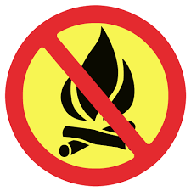
PROPANE CAMPFIRES ARE PERMITTED
CAMPFIRE BAN IN EFFECT
JULY 23, 2026 AT NOON

